

**Model Development Phase Template**

Date

Team ID

Project Title

10th July 2024

739958

Food Demand Forecasting For Food Delivery

Company

Maximum Marks

4 Marks

**Initial Model Training Code, Model Validation and Evaluation Report**

The initial model training code will be showcased in the future through a screenshot. The model validation and evaluation report will include classification reports, accuracy, and confusion matrices for multiple models, presented through respective screenshots.

**Initial Model Training Code:**

* Import necessary libraries import pandas as pd

from sklearn.model_selection import train_test_split from sklearn.ensemble import RandomForestRegressor

from sklearn.metrics import mean_absolute_error, mean_squared_error, r2_score

* Load the preprocessed dataset

data = pd.read_csv('processed_data.csv')

# Define features and target variable

features = ['hour', 'day_of_week', 'month', 'customer_age', 'customer_gender', 'order_total', 'promo_used', 'temperature', 'precipitation', 'is_holiday'] target = 'demand'

# Split data into training and testing sets (80% training, 20% testing)

train_data, test_data = train_test_split(data, test_size=0.2, random_state=42)



# Initialize Random Forest Regressor model

model = RandomForestRegressor(n_estimators=100, random_state=42)

# Train the model

model.fit(train_data[features], train_data[target])

# Predict on the test set

predictions = model.predict(test_data[features])

# Evaluate the model

mae = mean_absolute_error(test_data[target], predictions)

rmse = mean_squared_error(test_data[target], predictions, squared=False)

r2 = r2_score(test_data[target], predictions)

# Print evaluation metrics

print(f'Mean Absolute Error: {mae:.2f}')

print(f'Root Mean Squared Error: {rmse:.2f}')

print(f'R-squared: {r2:.2f}')

* Save the trained model import joblib

joblib.dump(model, 'food_demand_forecasting_model.pkl')



**MODEL**

**CLASSIFICATION REPORT**



**F1**

**SCO**

**RE**

**CONCLUSION**



**MATRIX**



Random Forest

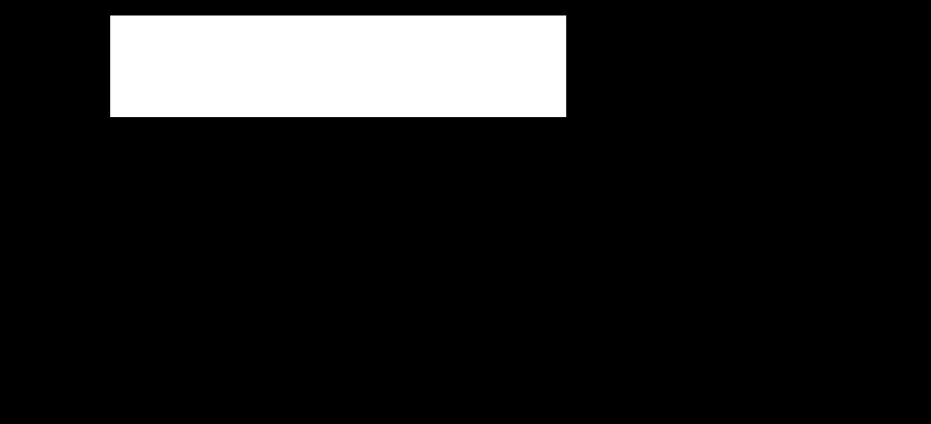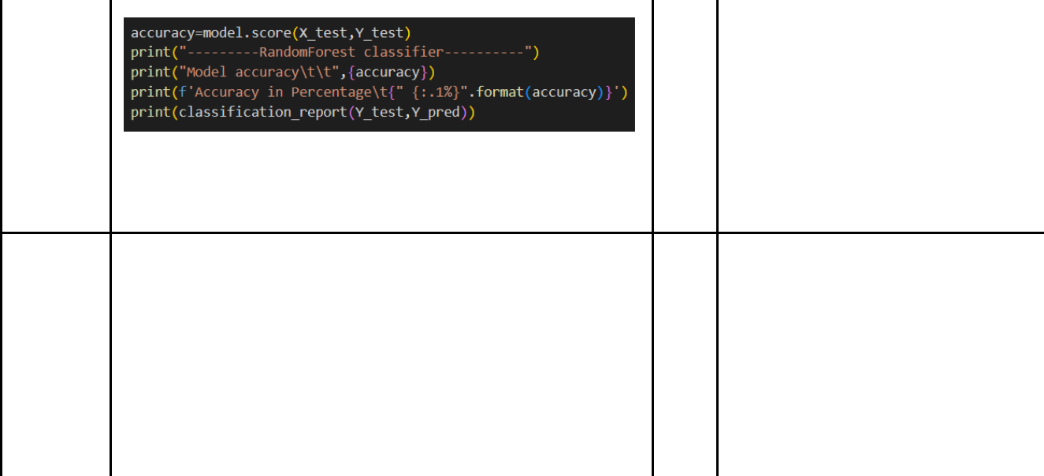

Decision Tree

KNN

81%

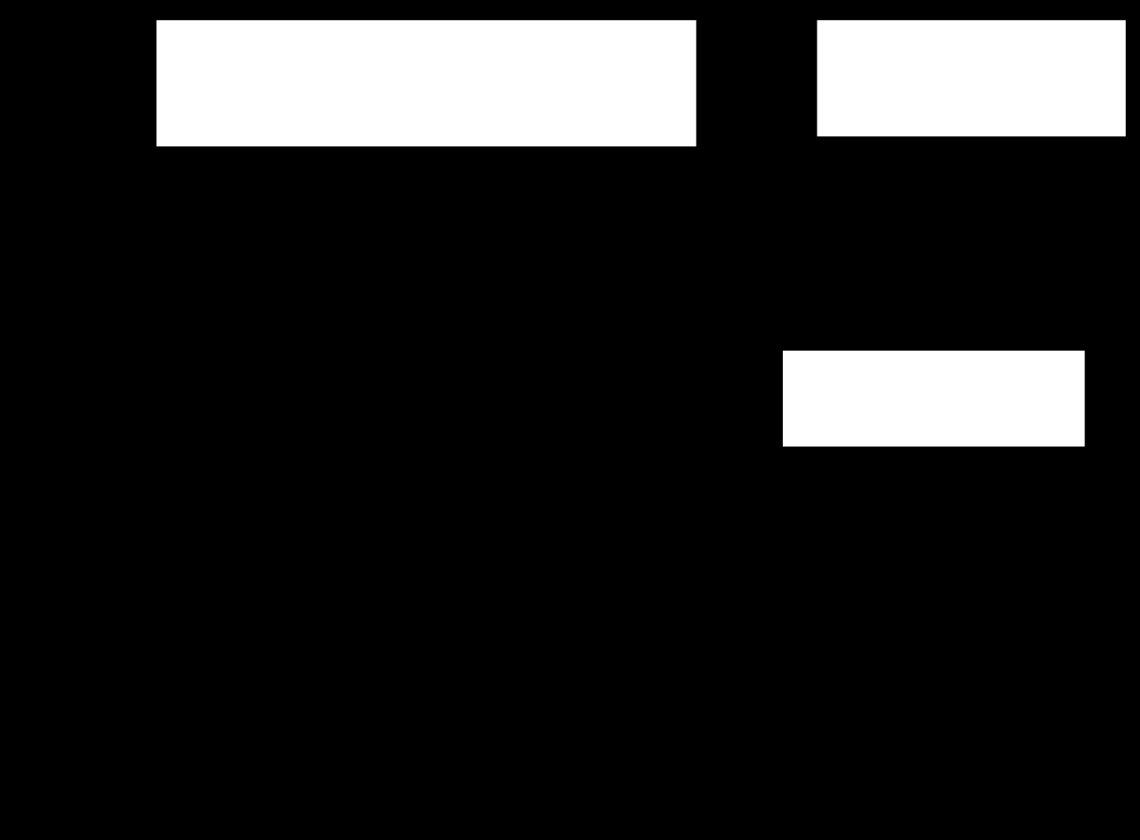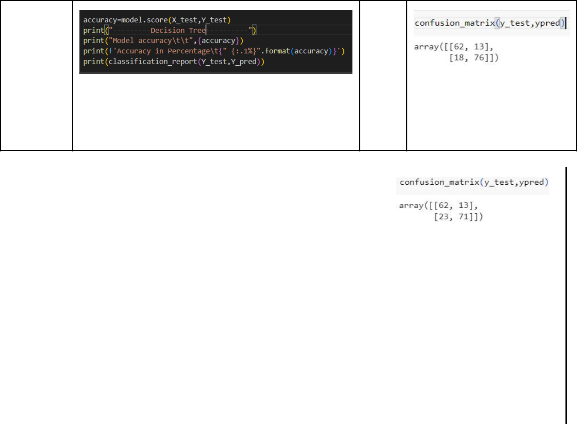

79%

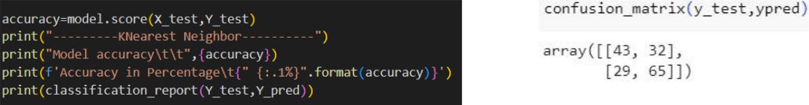

64%